Logo:

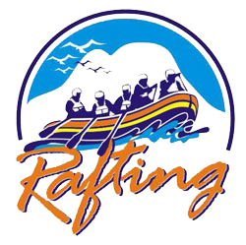

Color Palette:

<https://coolors.co/91c4f2-f4e8c1-837a75-0b3948>

Colors:

--primary-color: #F4E8C1

--secondary-color: #91C4F2

--accent1-color: #837A75

--accent2-color: #0B3948

Fonts:

HTML:

<link rel="preconnect" href="https://fonts.googleapis.com">

<link rel="preconnect" href="https://fonts.gstatic.com" crossorigin>

<link href="https://fonts.googleapis.com/css2?family=Roboto:wght@400;700&display=swap" rel="stylesheet">

CSS:

--heading-font: font-family: "Roboto", sans-serif; font-weight: 700; font-style: normal;

--text-font: font-family: "Roboto", sans-serif; font-weight: 400; font-style: normal;

:root {

    --div-primary-color : F4E8C1

    --div-secondary-color : 91C4F2

    --div-accent1-color : 837A75

    --div-accent2-color : 0B3948

    --div-heading-font : font-family: "Roboto", sans-serif; font-weight: 700; font-style: normal;

    --text-font : font-family: "Roboto", sans-serif; font-weight: 400; font-style: normal;

    --padding : 1rem;

    --border : 1px solid rgba(0,0,0,0.1):

}